Pictorial Essay on Issues of African Communities

PHOTOGRAPHIC ESSAY ON ISSUES OF AFRICAN

COMMUNITIES

LEROY CHRISTOPHER MWANGI

Registration Number: C026-01-1032/2021

Bachelor of science in Business information technology

July 2024

### The Impact of Access to Clean Water in African Communities

#### Introduction

Access to clean and safe drinking water is a fundamental human right and a critical issue in many African communities. This photographic essay explores the daily challenges faced by communities in obtaining clean water, the impact on their health and well-being, and the initiatives being undertaken to improve water access.

#### Introduction to the Issue

A panoramic view of a rural African village.

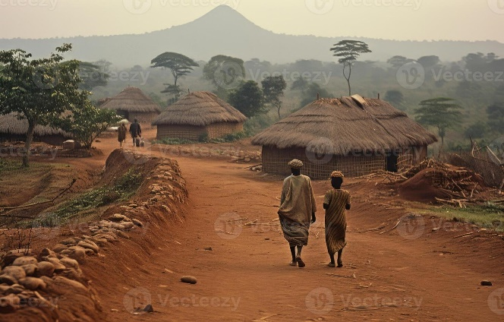

* **Caption**: Many African communities face daily challenges in accessing clean and safe drinking water.

#### Daily Struggle for Water

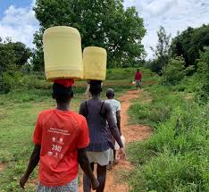

Women and children often travel several kilometers daily to fetch water, impacting their education and livelihoods.

#### Water Sources

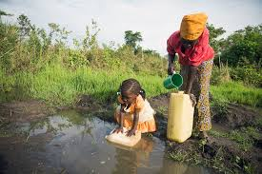

Many communities rely on unsafe water sources, leading to waterborne diseases.

#### Health Implications



Contaminated water is a leading cause of diseases such as cholera, dysentery, and typhoid.

#### Community Efforts

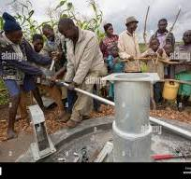

Local initiatives, supported by NGOs, are crucial in improving access to clean water.

#### Sustainable Solutions

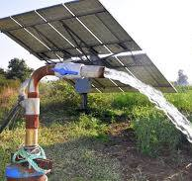

Sustainable solutions like hand-pump wells and solar-powered purification systems provide reliable access to clean water.

#### Education and Awareness

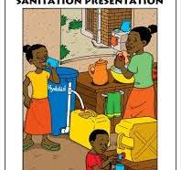

Educating communities about hygiene and sanitation is essential in preventing waterborne diseases.

#### Success Stories

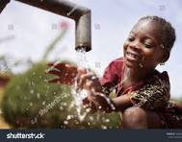

Successful water projects significantly improve the quality of life in affected communities.

#### Conclusion

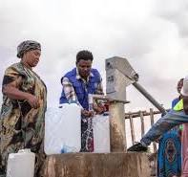

Access to clean water transforms lives, promoting health, education, and economic development.

#### Call to Action

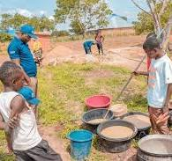

Support and involvement in clean water initiatives can make a significant difference. Together, we can ensure everyone has access to this vital resource.

#### Slide 12: References and Credits

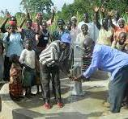

Acknowledge the efforts of NGOs, local communities, and international organizations working to improve water access.